**Project 1: Installing IIS web server in windows machine**

Step 1: Creating new windows instance in AWS

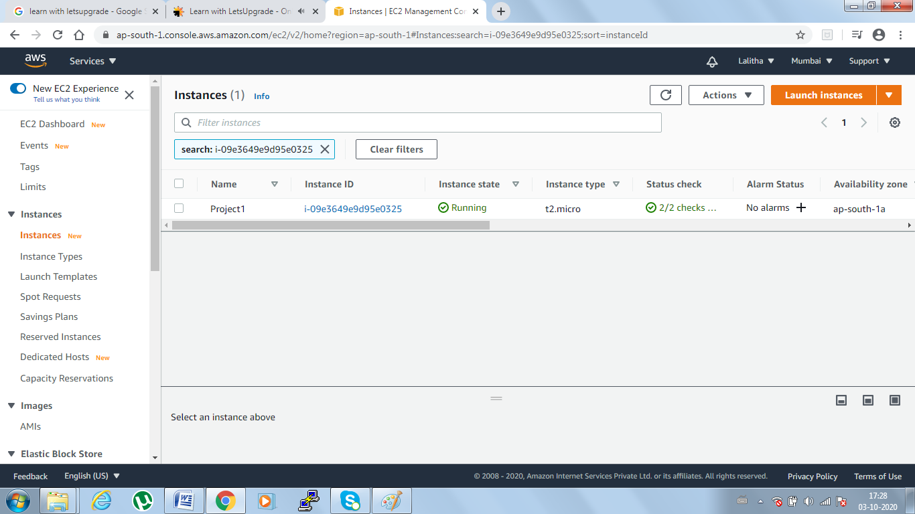

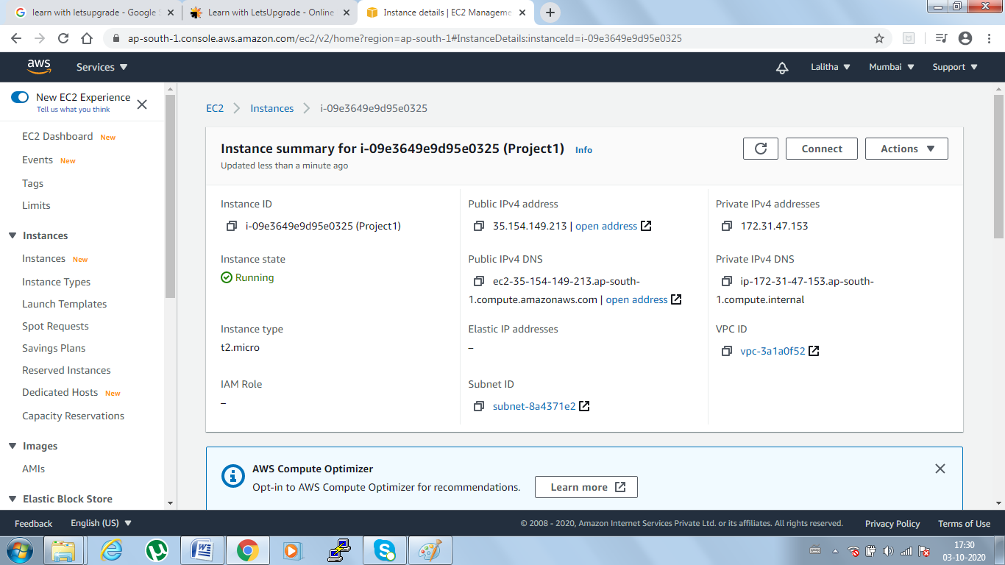

Step2 : Once instance is created, download the RDP machine -> get password -> decrypt password using existing “pem”file

Step 3: Once RDP machine connected , go to powershell and execute below command

To install IIS webserver use below command

Install-WindowsFeature -name Web-Server –IncludeManagementTools

Step 4: Once executed above command, need to hit the IP in new window which will display below screen

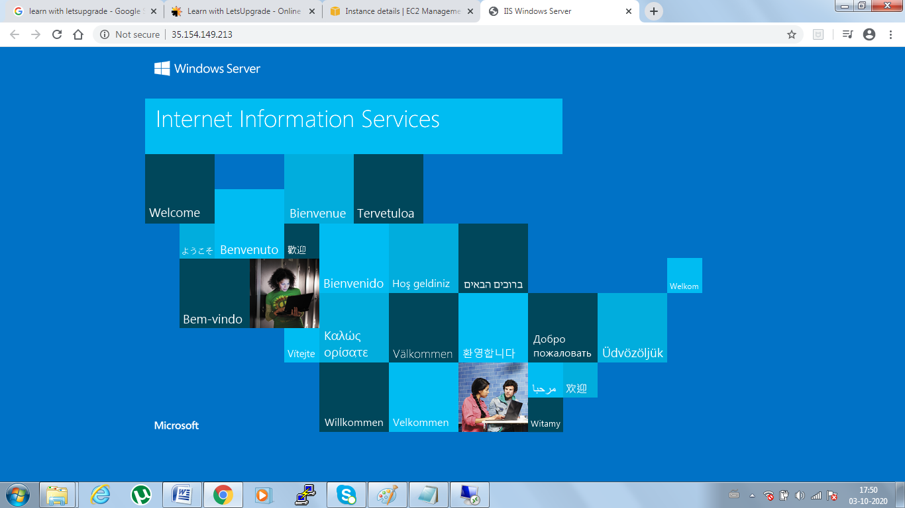

**Usecase:** I have stopped and started the windows instance later I could see public IP changed for the instance

So I have tried to hit the new IP and could see Windows server available under new IP but not old IP.

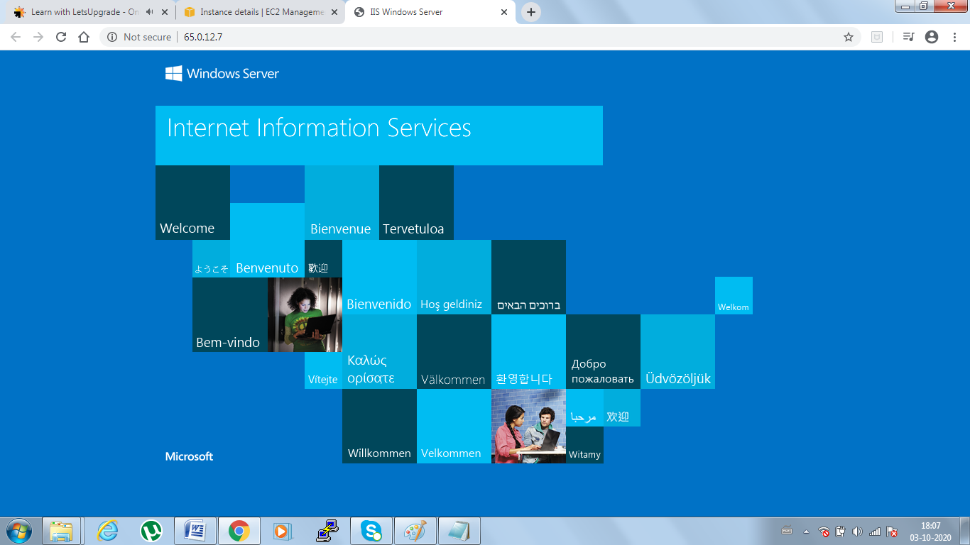

**Project 2: Install Nginx in new ubuntu machine**

Step 1: Launching new ubuntu instance

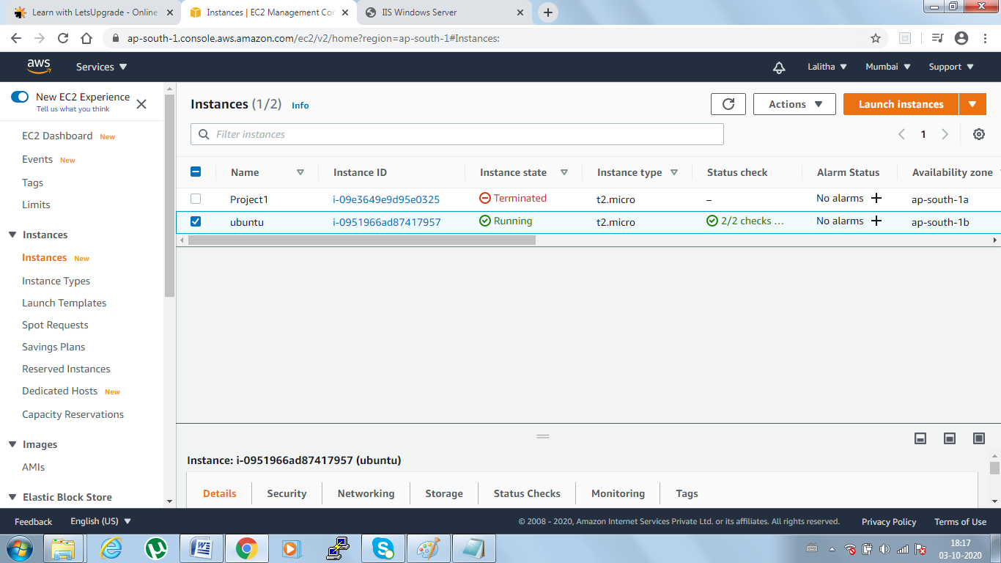

Step 2: Click on instaceid -> connect->Another page ->Under EC2 instance content -> Click on connect

Another window server will open here no need of putty etc ..,

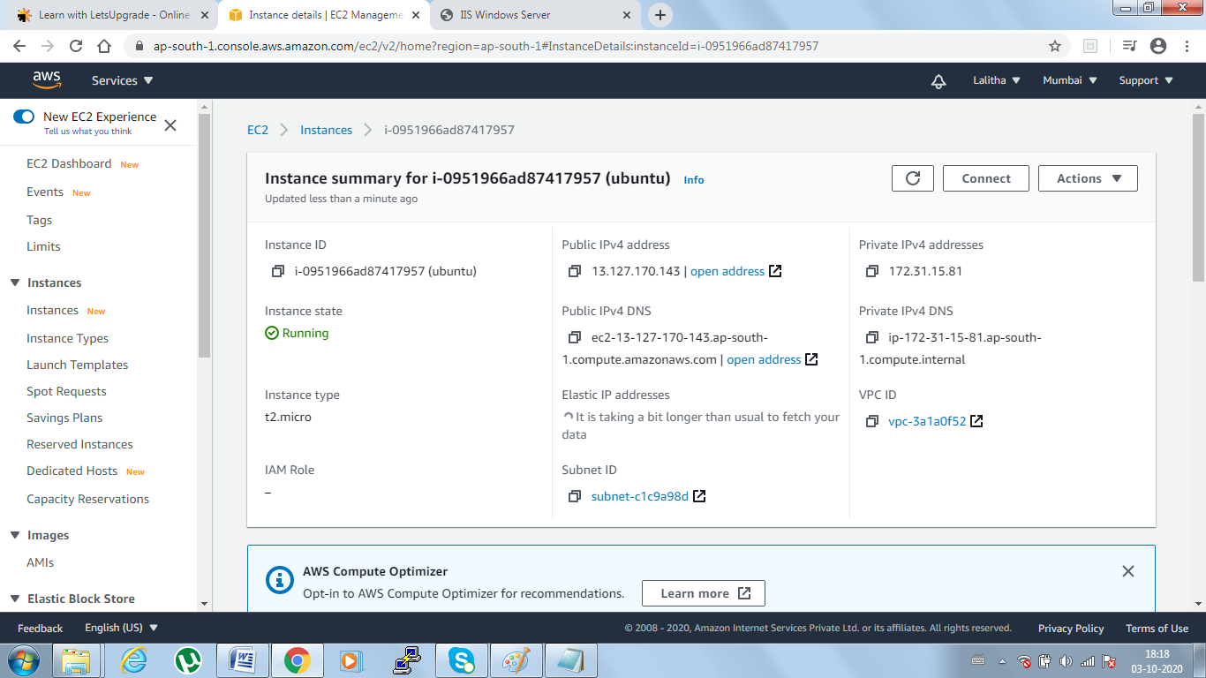

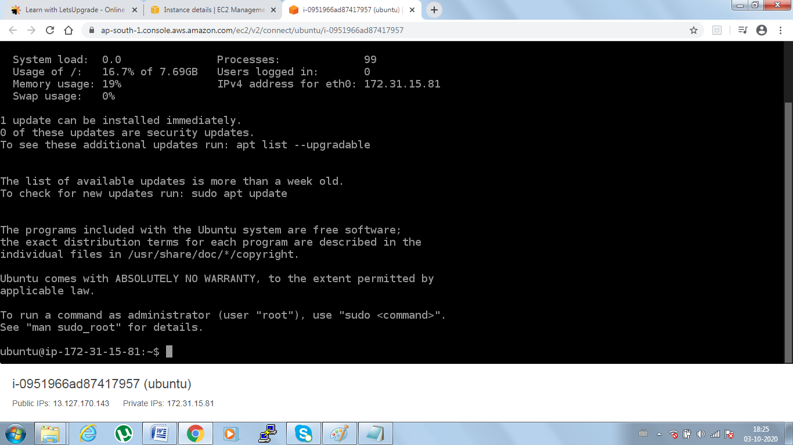

Step 3: Install ngnix webserver using bash

sudo apt-get -y update

sudo apt-get -y install nginx

Step 4: Copy the instance public ip and paste in new window

Welcome to nginx message will come as shown in below  
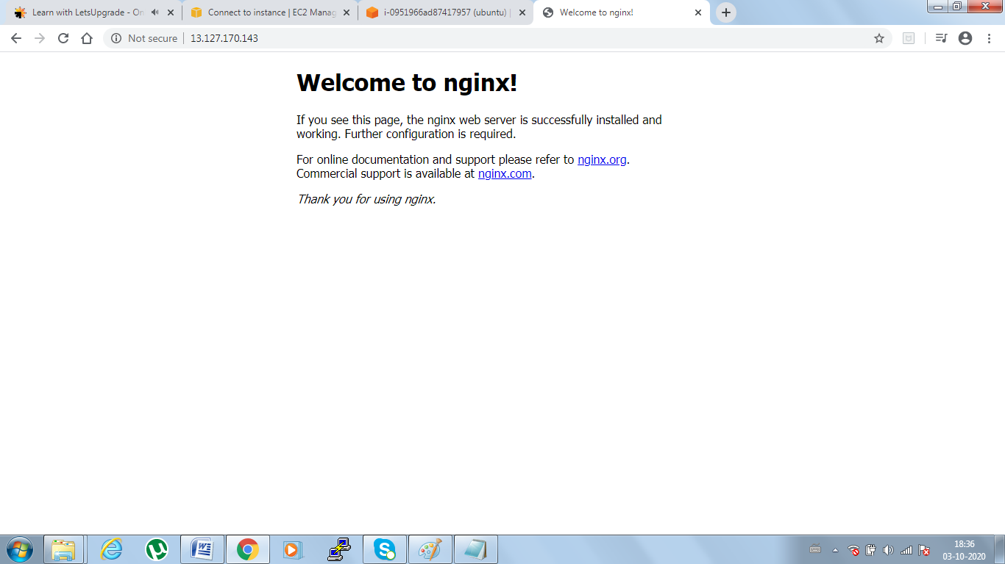

**Project 3 : Creating EBS volumes and assigning to running instance**

Step 1: First need to create an windows machine after that under EBS-> Volumes will show “in-use”

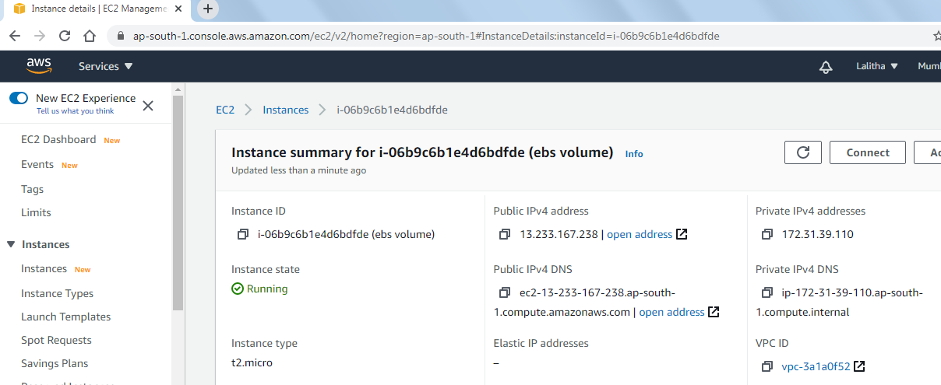

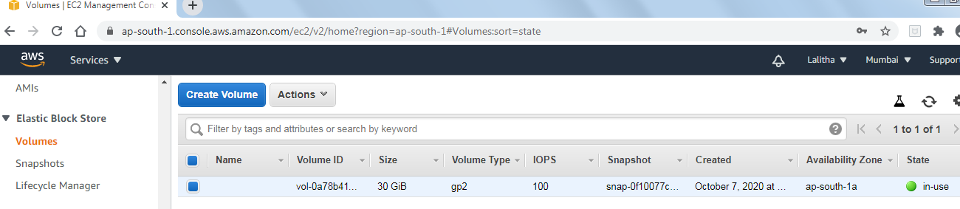

Step2 : Create new volume and attach it

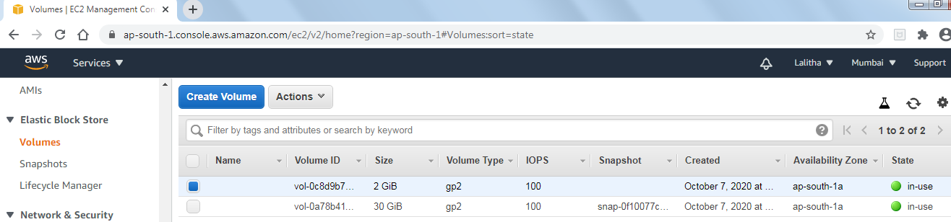

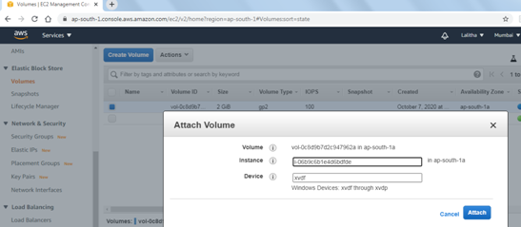

Step 3: Connect to RDP ->windows -> server manager-> All servers-> Files & Storage-> servies

* Volumes -> Disks

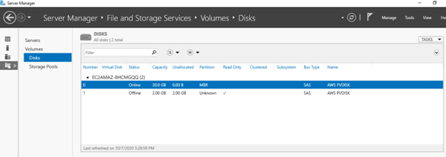

Step4: We have to make it online and follow the steps, once all steps completed you can see 2GB drive will created as shown in below

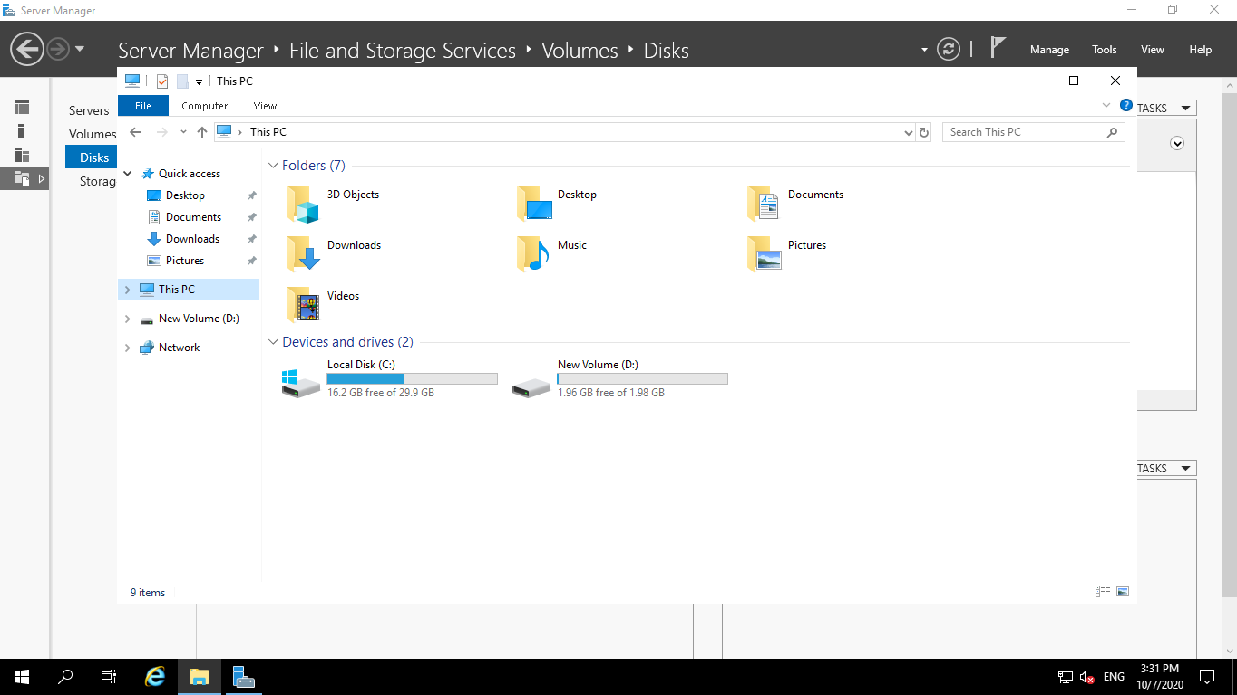

Step5: You can in instance storage session you can see 2GB is attached

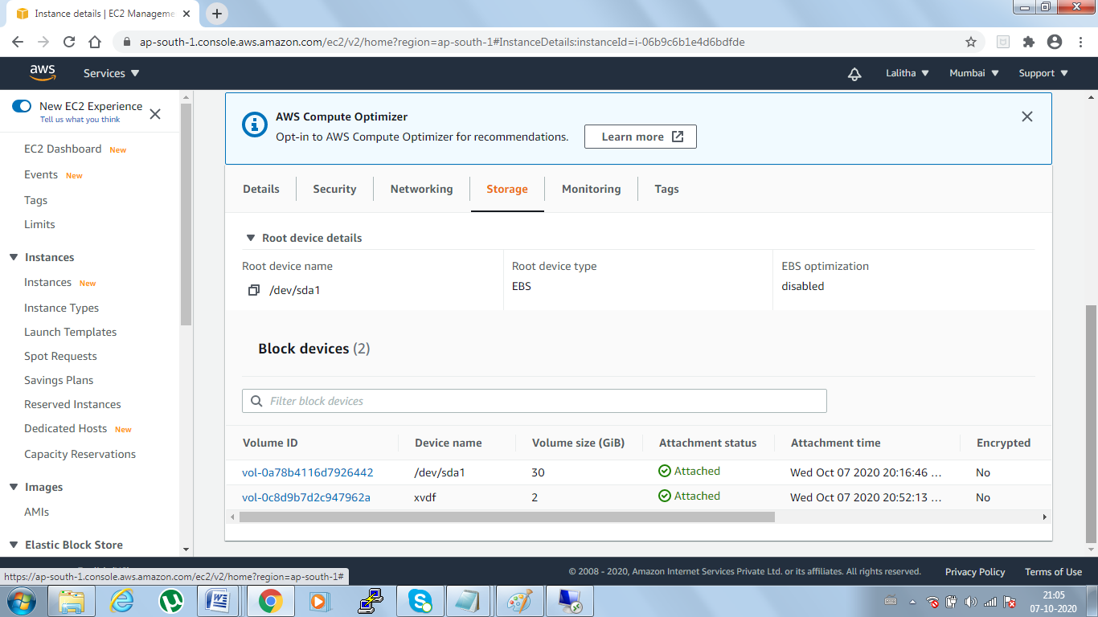

**Project 4: Working with Elastic IP Allocation**

Step1 : Create linux instance and install apache server in linux using below commands

sudo -s

sudo su

yum -y update

yum install httpd

systemctl start httpd

systemctl enable httpd

systemctl status httpd

Once all done try to click the public ip in new link

one apache test page will open

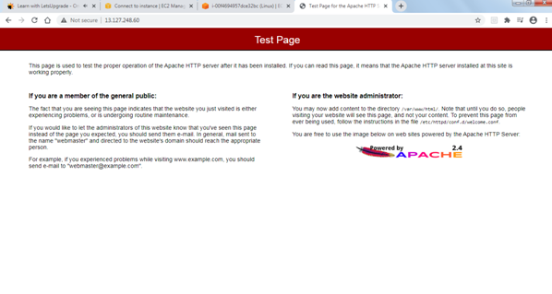

Step2: Under EC2 dashboard go to Network & Security -> Elastic IPs

Step 3: click on allocate elastic ip address -> amazon pool of IPs-> click on connect

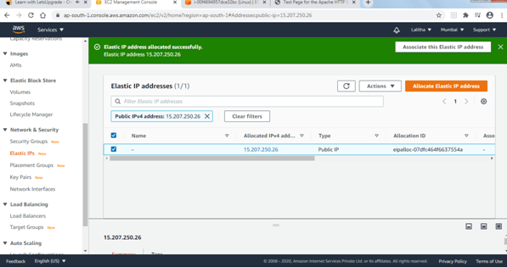

Step 4: select Eip -> Actions-> Associate Elastic IP address

Another page will come -> select Instance -> under seach which is running priveate ip address of running instance -> select allow this eip to reassociated -> and click on associate

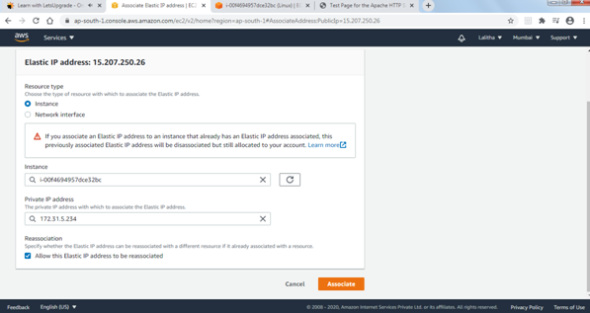

Step 5: Once done it will be associated with running instance

After that for our instance new IP will be assigned and with that ip only our apace will run

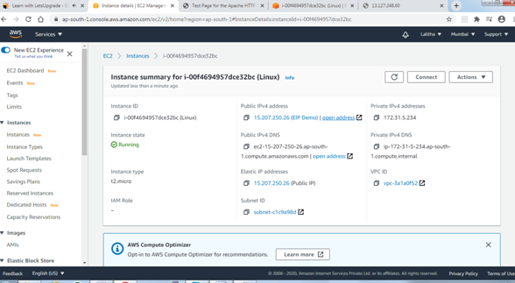

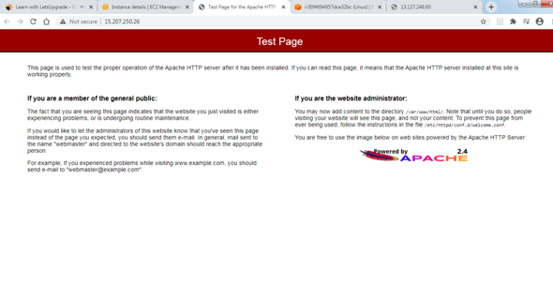

Step 6: Final terminate instance Go to elastic console ->and actions -> release eip as shown in below screen

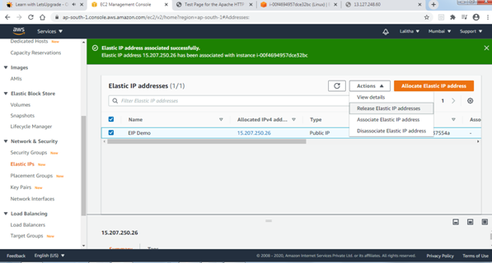

**Project 5: Working with** S3

Step 1: Create bucket under S3 console -> Create bucket

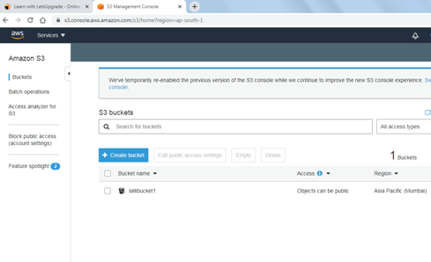

Step2: Once created click on bucked and upload the any sample image and once loaded click on object link which will throw error message

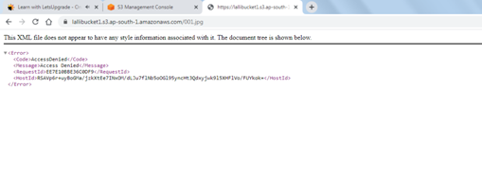

Step3 : Under bucket -> Permissions -> we have to apply public access to so that it will display once hit the object url

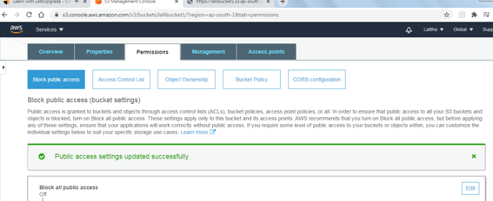

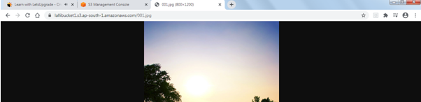

**Step 4: Static webhosting**

Go to bucket -> overview

upload the files which we created Index1.txt and Error1.txt to display in host

Properites -> static web hosting ->Over view -> right click on the files and make public

Copy the endpoint link under static web hosting  
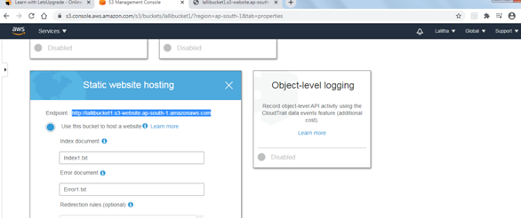

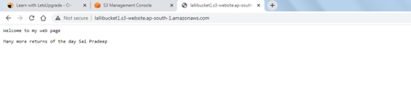

**Versioning :**

overview -> properties -> enable versioning ->upload file

In over view there is a tab Versions (Hide / show)

If we click on show it will show all the version Id's like when it was modified, version ID , after deleted delete marker will be present, latest version etc ..,

